D E T A I L S B E N E F I T S

Pre-Roll Video increases brand recall and has a positive impact on all devices.

Increase favorability

Boost brand association and engagement Drive intent to purchase advertised product
Pre-Roll Video drives click-throughs and shows positive
engagement across all devices.

:30 Pre-Roll Click-Through Rate = 87% Above Industry Average

:15 Pre-Roll Click-Through Rate = 371% Above Industry Average
Behavioral Targeting
Target consumers based on their behavior and tracked interest online.

Demographic Targeting
Target a specific age, income, and/or gender when trying to reach your consumers.

Frequency Targeting
Control frequency, limiting or increasing the number of times your ad is viewed.

Day Parting
Control when a user is able to see your sale message.

Geographic Targeting
Target a user based on their location, available by zip code, city, state, country, and radius. Custom geo fencing is also available.

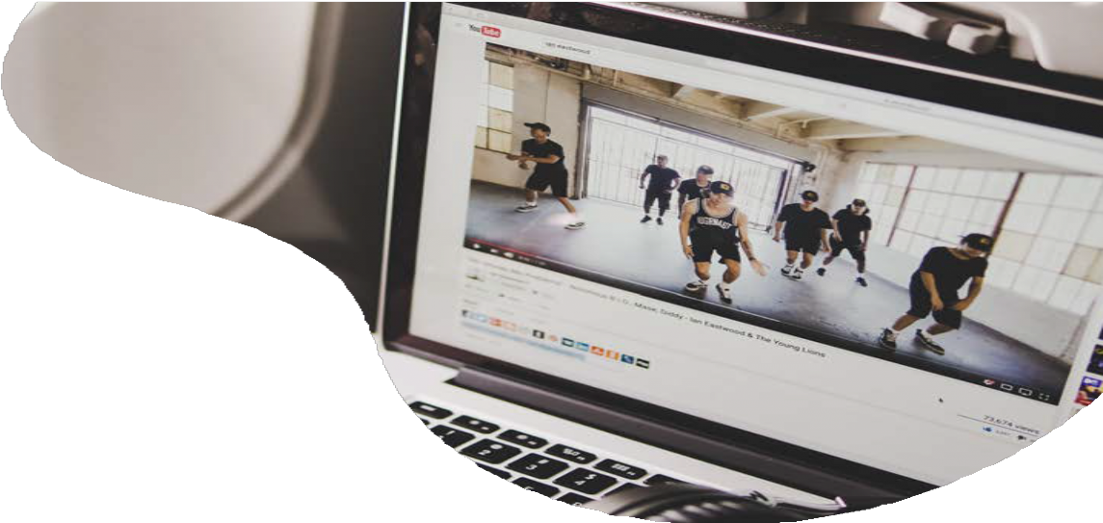
P R E - R O L L
V I D E O
P r e - R o l l V i d e o p l a y s y o u r 1 5 - s e c o n d , 3 0 -
s e c o n d o r l o n g - f o r m v i d e o w i t h i n o t h e r v i d e o c o n t e n t o n l i n e a t s c a l e .

P r e - R o l l i s a r o b u s t t o o l f o r p r e c i s e t a r g e t i n g a n d c a n i n c r e a s e b o t h b r a n d r e c a l l a n d i n t e n t t o
p u r c h a s e .
File types can include MP4, FLV, MOV, MPG and more with a file size of 200MB or lower. We recommend 30 seconds or less. See full specs at https://go.ui.marketing/product-specs

